# **BTD310- Lab 3**

Please work in **groups** to complete this lab. This lab is worth 2% of the total course grade and will be evaluated through your written submission, as well as the lab demo. During the lab demo, group members are randomly selected to present the answers to each of the lab questions. Group members not present during the lab demo will lose the demo mark.

Please submit the following files through Blackboard. Only one person must submit for the team.

* Lab3.sql must include a script including all the SQL commands for the following. Please write them in the specified order.
* Lab3.txt must be the output of the above script. Use the save button on top of the script results.

1. Create a new SQL worksheet in SQL Developer, save as **Lab3.sql**, and write SQL statements to do the following:
2. Create a report that produces the following (as shown in the sample):

* for employees with no commission:

*<employee first name>* earns *<salary>* monthly and no commission to afford spending *<salary / 3>* on housing.

* for employees with commission:

*<employee first name>* earns *<salary>* monthly and *<commission_pct as percentage>* commission to afford spending *<salary / 3>* on housing.

* Label the column as *Housing Expenses*.

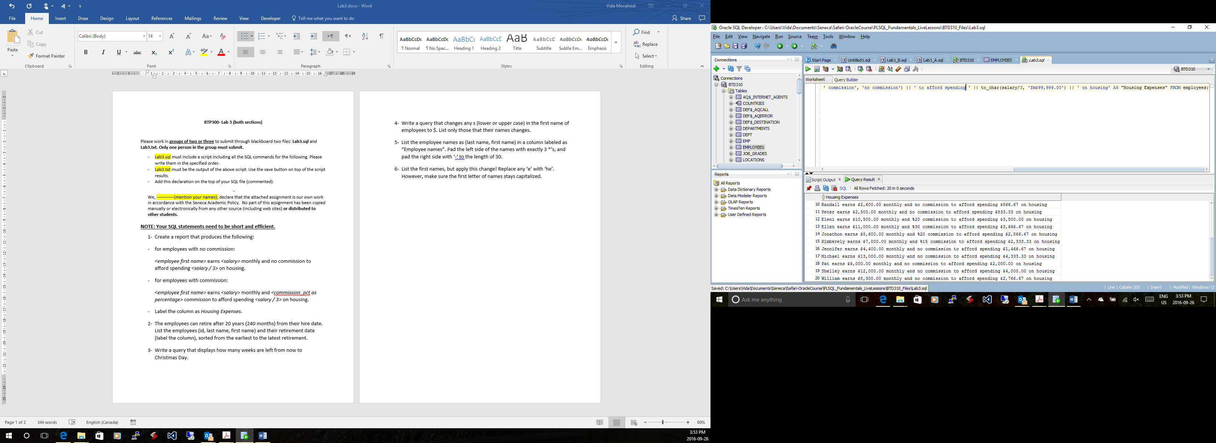

Lab3

1. Display each employee’s last name, hire date, and his 20th year celebration as shown in the sample below. Note that the celebration is the next Friday after his 20th year of employment. Pay attention to the formatting details.

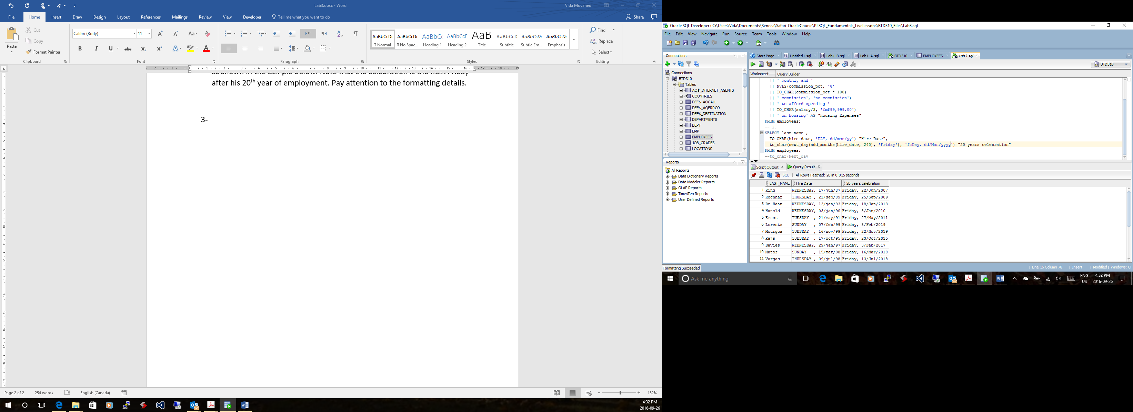

SELECT LAST_NAME, TO_CHAR(HIRE_DATE, 'DAY, DD/mon/YY') as "Hire Date",

TO_CHAR(NEXT_DAY(ADD_MONTHS(HIRE_DATE, 240),'FRIDAY'), 'fmDAY, DD/Mon/YYYY') as "20 years celebration"

FROM EMPLOYEES;

1. Display the hire dates of employees as shown in the sample, sorted by the day of the week, starting with Monday.

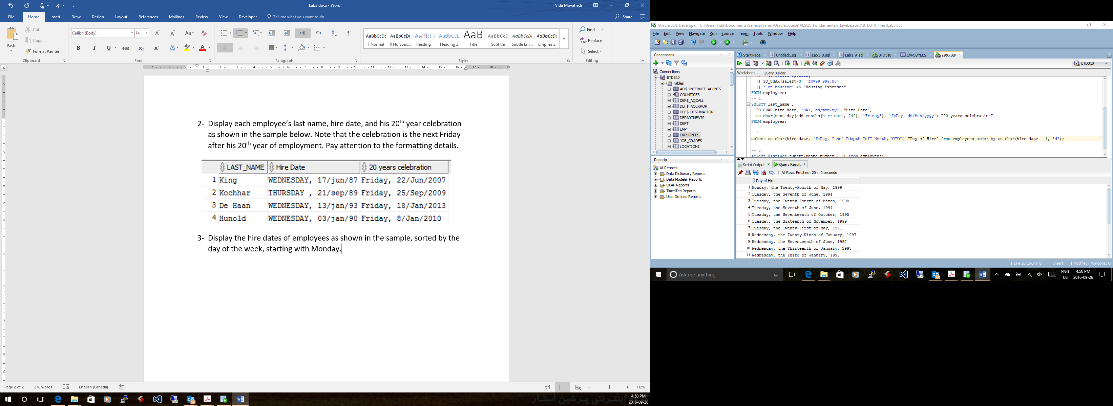

SELECT TO_CHAR(HIRE_DATE, 'fmDAY, "the" DdSpth "of" Month, YYYY') as "Day of Hire"

FROM EMPLOYEES

ORDER BY (NEXT_DAY(HIRE_DATE,'MONDAY') - HIRE_DATE) DESC;

1. Using the DECODE function, write a query that displays the region of the phone number of each employee, using the following data, as shown in sample:

|  |  |
| --- | --- |
| **Phone number starting with** | **Region** |
| 515 | A |
| 590 | B |
| 603 | C |
| 650 | D |
| None of the above | E |

Order by region, and within each region, by phone number.

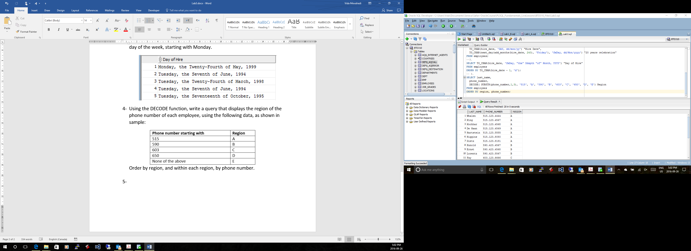

SELECT LAST_NAME, PHONE_NUMBER,

DECODE(SUBSTR(PHONE_NUMBER,1,3),

'515', 'A',

'590', 'B',

'603', 'C',

'650', 'D',

'E') AS REGION

FROM EMPLOYEES

ORDER BY REGION, PHONE_NUMBER;

1. Rewrite the statement in the preceding exercise using the CASE syntax.

SELECT LAST_NAME, PHONE_NUMBER,

CASE SUBSTR(PHONE_NUMBER,1,3)

WHEN '515' THEN 'A'

WHEN '590' THEN 'B'

WHEN '603' THEN 'C'

WHEN '650' THEN 'D'

ELSE 'E' END AS REGION

FROM EMPLOYEES

ORDER BY REGION, PHONE_NUMBER;

1. Create a query that will display a 1 if the employee was hired in 1995, and a 0 otherwise, as shown in the sample.

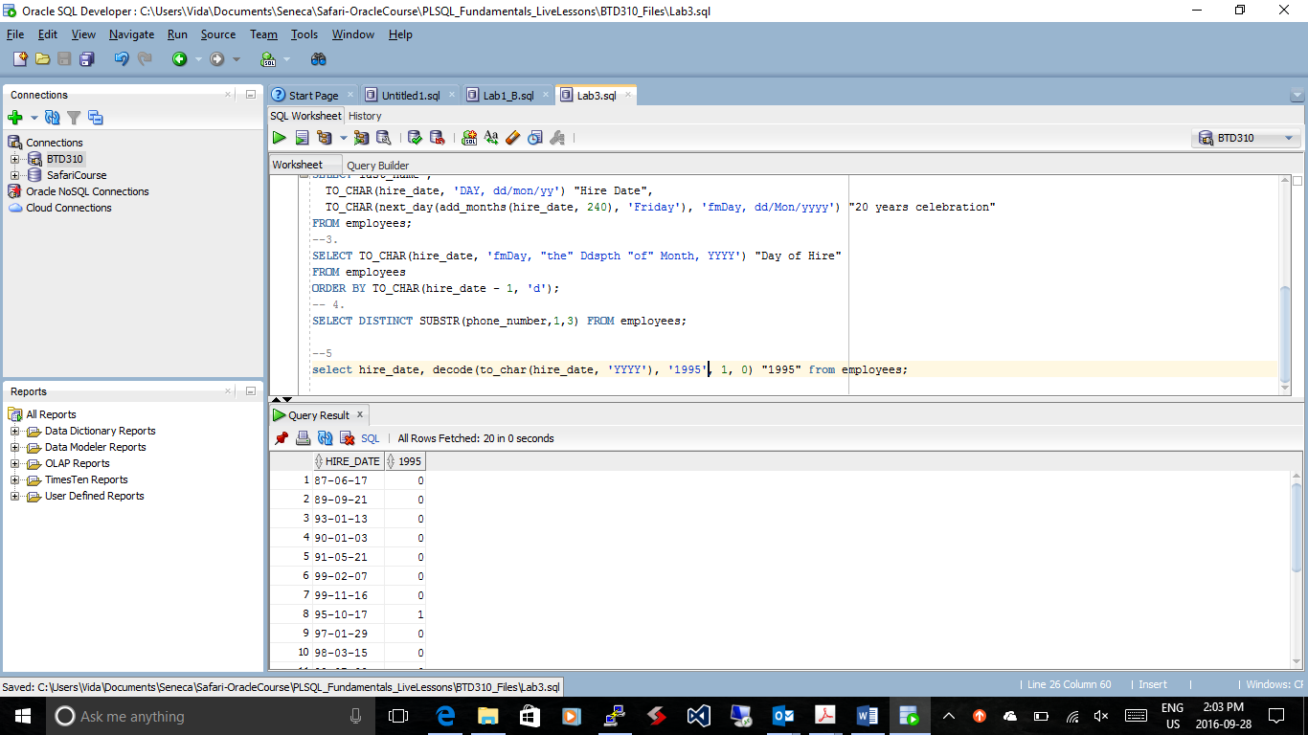

SELECT HIRE_DATE,

CASE TO_CHAR(HIRE_DATE, 'YY')

WHEN '95' THEN '1'

ELSE '0' END AS "1995"

FROM EMPLOYEES;

1. Add a comment before each answer to specify the question number. For example,

-- Question 3

1. Use SQL Developer to format your script.
2. Clear the script output. Then run your script (F5). Save the output as **Lab3.txt**.
3. Add this declaration on the top of your Lab3.txt file.

We, Khai, Mahnoor, and Hao declare that the attached assignment is our own work in accordance with the Seneca Academic Policy. No part of this assignment has been copied manually or electronically from any other source (including web sites) **or distributed to other students.**

1. Also, on top of Lab3.txt, specify what each member has done towards the completion of this work:

Name Task(s)

1-

2-

3-